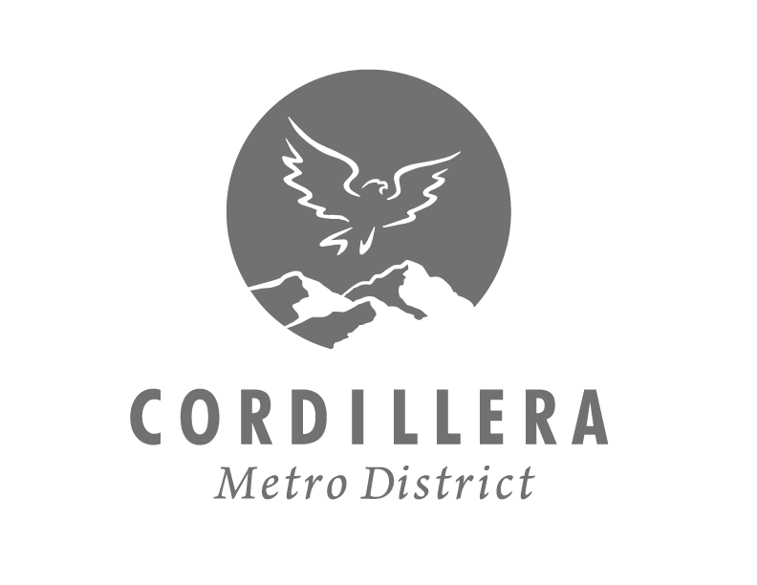

Meeting Agenda

DATE: TUESDAY, JULY 19, 2022
TIME: 3:00PM
LOCATION: 543 CARTERVILLE RD, CORDILLERA, CO 81632
STATE OF COLORADO) County of EAGLE) SS.

Special Board Meeting
BOARD OF DIRECTORS

Cheryl Foley, President – May 2025 | Dan Roberts, Vice President – May 2023
Richard Saxby, Treasurer – May 2025 | Harry Jasper, Secretary – May 2025 | Rob Meyer, Assistant Treasurer & Secretary – May 2023

call to Order - 3:00Pm
- Call to Order
- Declaration of Quorum/Director Qualifications/Disclosure
- Approval of Agenda

Dissussion items – 3:01pm
- Meet your board members

public comments – 3:02m
CMD welcomes public comment.

Adjourn – 6:00Pm
NOTICE IS HEREBY GIVEN that the Board of Directors of the Cordillera Metropolitan District will hold a meeting. CMD is required to meet a 24-hour posting requirement unless in the event of an emergency. By Order of the District, Cheryl Foley.

